**SONIA FOR STUDENTS MOBILE APP – Instructions for downloading**

Firstly you will need to log into Sonia Online by:

* Logging into MySCU
* Selecting “Placements (Sonia)” located under Useful Links
* This will take you directly to Sonia Online
* Alternatively you can click on this link - [Access Sonia Online here](https://sonia.scu.edu.au/SoniaOnline/Default.aspx)

Once you are in Sonia Online:

* Select the cog on the top right hand side of the screen
* This will the open an option for you to “Connect the Sonia for Students Mobile App”
* 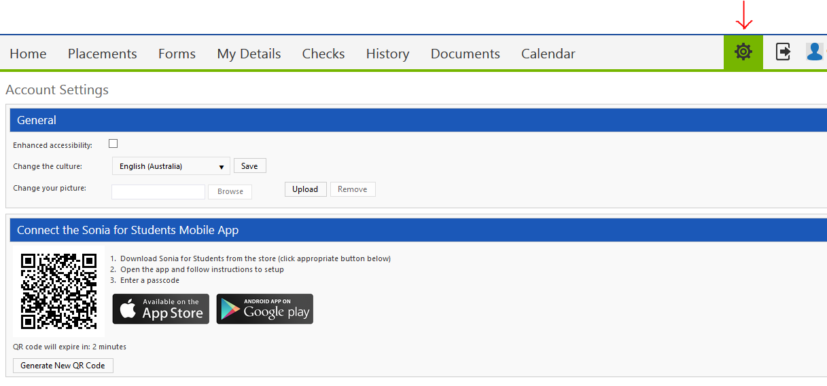Please follow the instructions provided within this option to download the App