Office of the Pro-Vice Chancellor (Academic Quality)

Guide and Template for Unit Assessors email to Student

This guide and email template is for Unit Assessors who require a student to verbally answer questions about an assessment submission in order to further verify the authenticity of the submission, under Clause (16) of the Academic Integrity Procedures.

Guide Status and Details

Effective Date: 27.9.23. updated 3.10.23

Approval Authority: Pro Vice Chancellor (Academic Quality)

Head of Work Unit: Professor Thomas Roche

Enquiries: Dot Armstrong

Policy document

Academic Integrity Procedures
Link https://policies.scu.edu.au/document/view-current.php?id=337#section4

Background
The Academic Integrity Procedures defines the role of Markers, UAs and AIOs in regard to academic integrity breaches at Section 4.
- The Marker is responsible for identifying academic integrity breaches, and submitting (along with evidence) into AIMS.

- The Unit Assessor (UA) is responsible for reviewing and deciding Minor breaches.

  - The UA may require a student to verbally answer questions about an assessment submission in order to further verify the authenticity of the submission (Clause 16). Use the template email at Attachment A below for the purpose of arranging a meeting with the student. Your questions during the meeting should focus on the submission and relate to any signals of a potential academic integrity breach identified by the Marker or yourself. These might have been recorded in the Guide & Template Signals of a Breach & Record of Evidence for AIMS and uploaded to AIMS. If not, it is useful to complete this template before any interview, as it will guide you to what questions you might ask the student. For example, if the student has NOT completed the assessment task that was set (e.g., the task asked for X and the student did Y), ask them why they did not. Use Attachment B: Template For Record of UA interview with student below, to record your questions and the student’s response. Remember, this meeting is aimed at providing them the opportunity to demonstrate it is their own work. Do they understand and can explain the content they submitted?

- The Academic Integrity Officer (AIO) is responsible for reviewing and deciding Moderate and Major breaches.

Flowchart – the 3 key Roles
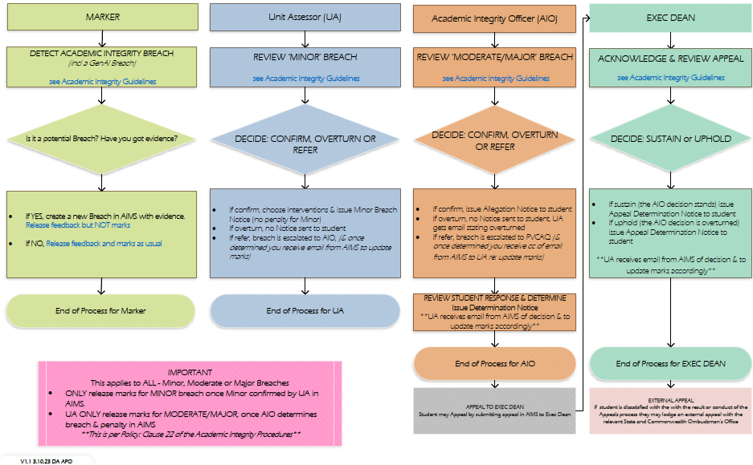

Attachment A: Template email – UA to student

Email: use student SCU email address
Subject: invitation to discuss your assessment submission
Dear Student,
As the Unit Assessor for Unit x, I have received notification of a possible breach of academic integrity regarding your assessment item x.
In order to further verify the authenticity of your assessment, I invite you to meet with me to answer questions about the assessment submission, at the date and time noted below:
Insert Zoom or Teams date/time/link
This action is available to me under Clause (16) of the Academic Integrity Procedures.
You are welcome to invite a support person to this meeting. Please note the support person cannot be a legal representative, and cannot answer questions on your behalf. The University offers a free, confidential and independent student advocacy service to all enrolled students. Further information is available on the website Student Advocacy Service.
Following this meeting, or if you decline to meet, I will proceed to make my decision on the basis of the evidence available, in accordance with the Student Academic and Non-Academic Misconduct Rules
Yours sincerely,
Insert name, Unit Assessor for x (or use usual email signature line)

Attachment B: Template For Record of UA interview with student
UA Questions
- Can you tell me why…
Student response:
- Can you show me how…
Student response:

